A REPORT

ON
AI-Powered Student Assistant Learning

Submitted by

Ms. Sneha S - 20241CSE0846

Under the guidance of,
Mr. Sakthi S
Assistant Professor

in partial fulfillment for the award of the degree of
BACHELOR OF TECHNOLOGY

IN

COMPUTER SCIENCE AND ENGINEERING

AT



PRESIDENCY UNIVERSITY
BENGALURU
AUGUST 2026

PRESIDENCY UNIVERSITY

PRESIDENCY SCHOOL OF COMPUTER SCIENCE AND ENGINEERING

CERTIFICATE

This is to certify that the report of CSE7000 – Internship on “AI-Powered Student Assistant Learning” being submitted by “SNEHA S” bearing roll number “20241CSE0846” in partial fulfillment of the requirement for the award of the degree of Bachelor of Technology in Computer Science and Engineering is a bonafide work carried out under our supervision.

Mr. Sakthi S  Assistant Professor  PSCS  Presidency University | Ms. Shaik Salma Begum  Assistant Professor  PSCS  Presidency University | Dr. Balakrishnan R  Programme Internship  coordinator  Associate Professor  PSCS  Presidency University

Dr. Bhuvaneshwari Patil  School level Internship  coordinator  Assistant Professor  PSCS  Presidency University | Dr. Asif Mohamed H B  Associate Professor  HOD  PSCS  Presidency University | Dr. Duraipandian N  Dean – PSCS  Presidency University

PRESIDENCY UNIVERSITY

PRESIDENCY SCHOOL OF COMPUTER SCIENCE AND ENGINEERING

DECLARATION

I hereby declare that the work, which is being presented in the report entitled “AI-Powered Student Assistant Learning” in partial fulfillment for the award of Degree of Bachelor of Technology in Computer Science and Engineering is a record of my own investigations carried under the guidance of Mr. Sakthi S, Assistant Professor and Ms. Shaik Salma Begum, Assistant Professor, Presidency School of Computer Science and Engineering, Presidency University, Bengaluru.

I have not submitted the matter presented in this report anywhere for the award of any other Degree.

Sneha S,
20241CSE0846

INTERNSHIP COMPLETION CERTIFICATE

ACKNOWLEDGEMENT

First of all, I indebted to the GOD ALMIGHTY for giving me an opportunity to excel in our efforts to complete this internship on time.
I express sincere thanks to our respected Dean Dr. Duraipandian N, Presidency School of Computer Science and Engineering, Presidency University for getting us permission to undergo the internship.
I express heartfelt gratitude to our beloved Dr. Asif Mohammad, Head of the Department, Presidency School of Computer Science and Engineering, Presidency University, for rendering timely help in completing this internship successfully.
I am greatly indebted to my reviewers Mr. Sakthi S, Assistant Professor and Ms. Shaik Salma Begum, Assistant Professor, Presidency School of Computer Science and Engineering, Presidency University for their inspirational guidance, and valuable suggestions and for providing a chance to express technical capabilities in every respect for the completion of the internship work.
I would like to convey gratitude and heartfelt thanks to the Internship Coordinator Dr. Bhuvaneshwari Patil and Program Internship Coordinator Dr. Balakrishnan R. I also thank my family and friends for the strong support and inspiration they have provided us in bringing out this internship.

Sneha S (20241CSE0846)

ABSTRACT
The AI-Powered Student Assistant Learning project was developed as part of the Intensive AI GPU Summer Internship Program (Summer 2026) at Presidency University through the Presidency School of Artificial Intelligence and Advanced Computing and the AI Centre of Excellence accelerated by NVIDIA. The project addresses the difficulty students face in processing large volumes of study material, preparing learning resources, and accessing personalized academic support efficiently.
The system is implemented as a web-based application using Python and Flask for backend processing, HTML, CSS, JavaScript, and Jinja2 for the user interface, and SQLite for data storage. Students can upload or provide learning materials in supported formats for processing. The application extracts relevant content and uses the Groq Cloud API with LLaMA models for AI-assisted generation. The system generates summaries, revision notes, flashcards, quizzes, explanations, and other learning resources. Quiz and performance-related information is further used to support feedback, self-assessment, and personalized learning functions. The application also integrates document processing, AI content generation, academic support, and database-backed learning features into a unified platform.
The system was evaluated using 1 primary CSV dataset, 2 JSON datasets, and 17 uploaded multi-format test files. A total of 17 logged AI API queries were executed successfully, resulting in a 17/17 API success rate (100%) for the recorded test calls. The project also generated 40 AI-assisted flashcard pairs, while 36 quiz question items were evaluated through four live quiz attempts. The measured average AI response latency was 1.948 seconds, with a fastest recorded response of 0.970 seconds and a maximum of 3.817 seconds.
The developed system reduces the manual effort required to prepare learning resources and provides students with a centralized environment for AI-assisted learning, self-assessment, and academic support. It demonstrates the practical integration of Generative AI, document processing, web development, and data management to create a more organized and interactive learning experience.

TABLE OF CONTENTS
SL. NO. | TITLE | PAGE NO.
 | ACKNOWLEDGEMENT | v
 | ABSTRACT | vi
1. | INTRODUCTION AND COMPANY PROFILE | 1
 | 1.1 Industry Background | 1
 | 1.2 Organizational and Internship Context | 1
 | 1.3 Problem Statement | 1
 | 1.4 Objectives | 2
 | 1.5 Project Overview | 2
 | 1.6 Scope of the Project | 2
2. | REQUIREMENTS ANALYSIS AND SYSTEM DESIGN | 4
 | 2.1 Software Requirements Specification | 4
 | 2.2 Functional Requirements | 4
 | 2.3 Non-Functional Requirements | 4
 | 2.4 Hardware Requirements | 5
 | 2.5 Software Requirements | 5
 | 2.6 System Architecture | 5
 | 2.7 Data Flow | 6
 | 2.8 Technology Stack | 7
3. | TECHNICAL IMPLEMENTATION AND CORE MODULES | 8
 | 3.1 Project Implementation Overview | 8
 | 3.2 Algorithm / Execution Steps | 8
 | 3.3 Study Material Processing | 9
 | 3.4 AI-Assisted Content Generation | 9
 | 3.5 Quiz and Assessment Module | 9
 | 3.6 Personalized Learning Features | 9
 | 3.7 Backend and Database Implementation | 9
 | 3.8 Frontend Implementation | 10
 | 3.9 AI Service Integration | 10
 | 3.10 System Integration and Workflow | 10
4. | TESTING, VERIFICATION AND QUALITY ASSURANCE | 11
 | 4.1 Testing Overview | 11
 | 4.2 Functional Verification | 11
 | 4.3 AI Content and Integration Verification | 11
 | 4.4 Performance Validation and Quality Assurance | 12
5. | RESULTS AND DISCUSSION | 13
 | 5.1 Results Overview | 13
 | 5.2 Student Dashboard and Performance Overview | 13
 | 5.3 AI-Generated Quiz Assessment | 14
 | 5.4 AI-Generated Study Summary | 14
 | 5.5 Personalized Study Plan | 15
 | 5.6 Academic Performance and GPA Analysis | 16
 | 5.7 User Interface and Output Artifacts | 17
 | 5.8 Discussion and Summary of Results | 17
6. | CHALLENGES ENCOUNTERED AND SOLUTIONS | 19
 | 6.1 Challenges During System Development | 19
 | 6.2 AI Integration Challenges and Solution | 19
 | 6.3 Content Processing and Integration Challenges | 19
 | 6.4 Performance and Data Challenges | 20
 | 6.5 Overall Solutions Applied | 20
7. | CONCLUSION AND FUTURE ENHANCEMENTS | 21
 | 7.1 Conclusion | 21
 | 7.2 Future Enhancements | 21
 | REFERENCES | 22
 | APPENDICES | 23

LIST OF FIGURES
FIG.NO. | TITLE | PAGE NO.
2.1 | System Architecture of the AI-Powered Student Assistant Learning System | 6
2.2 | Data Flow of the AI-Powered Student Assistant Learning System | 7
5.1 | Student Dashboard and Performance Overview | 13
5.2 | AI-Generated Quiz Assessment | 14
5.3 | AI-Generated Study Summary | 15
5.4 | Personalized Study Plan | 16
5.5 | GPA Analysis Dashboard | 17
A.1 | Backend Application Configuration Code | 24
A.2 | Learning Material Processing and Storage Code | 25
A.3 | Software Dependencies | 26
B.1 | Database DDL Script of the AI-Powered Student Assistant Learning System | 28

CHAPTER 1
INTRODUCTION AND COMPANY PROFILE
1.1 Industry Background
The rapid advancement of Artificial Intelligence has significantly transformed the education sector. Students increasingly require tools that can help them understand concepts, organize study material, practise through assessments, and receive timely feedback. Conventional learning methods often require considerable manual effort to prepare summaries, revision notes, flashcards, quizzes, and study plans from large volumes of academic material.
Generative AI, Natural Language Processing, and Large Language Models provide a foundation for intelligent educational systems. These technologies can process textual information, generate learning resources, support question answering, and assist with personalized learning workflows. An AI-powered student assistant can therefore reduce repetitive preparation effort while supporting self-paced and interactive learning.
1.2 Organizational and Internship Context
The AI GPU Summer Internship Program was conducted at Presidency University through the AI Centre of Excellence accelerated by NVIDIA. The internship was a hands-on program covering Artificial Intelligence, Machine Learning, Deep Learning, Transformer architectures, Large Language Models, Generative AI, Full-Stack Web Development, and GPU-accelerated computing.
The program included theoretical sessions, coding exercises, laboratory activities, GPU-based practical sessions, and capstone project development. The knowledge gained during the internship was applied to develop the AI-Powered Student Assistant Learning project, which integrates AI-assisted content generation, learning support, performance-oriented features, and web application development into a single educational platform.
1.3 Problem Statement
Students frequently work with lengthy textbooks, lecture notes, PDF documents, and other learning resources. Preparing concise summaries, revision notes, flashcards, quizzes, and practice questions manually is time-consuming and may not provide consistent personalization. Students may also find it difficult to identify weak areas and organize an effective study plan.
A centralized learning assistant is therefore required to process selected learning content, generate useful study resources, support self-assessment, and provide organized learning assistance. The system should simplify access to learning tools while maintaining a user-friendly workflow.
1.4 Objectives
• To develop an AI-powered platform that assists students with study material processing and learning support.
• To generate summaries, revision notes, flashcards, quizzes, explanations, and practice-oriented content from supported learning materials.
• To provide self-assessment and feedback mechanisms that help students identify areas requiring further revision.
• To support personalized study planning and selected academic performance analysis features.
• To integrate AI services, document processing, database support, and a responsive web interface into one application.
1.5 Project Overview
The AI-Powered Student Assistant Learning project was developed as the capstone application of the internship. The system provides a web-based environment in which students can access AI-assisted learning tools and generate useful study resources from selected academic content.
The application processes supported learning material, prepares relevant textual context, and sends suitable requests to the configured AI service. Depending on the selected feature, the system can produce summaries, key points, revision notes, flashcards, quizzes, explanations, and other learning outputs. Relevant interactions and selected performance information can be used to support feedback and personalized learning functions.
1.6 Scope of the Project
The project focuses on AI-assisted educational support through document processing, content generation, self-assessment, study planning, and performance-oriented features. It includes a web interface, backend processing, AI service integration, and database support for relevant application data.
The system is intended to assist students in their learning process and does not replace teachers, academic evaluation, or verified subject expertise. AI-generated content should be reviewed when high academic accuracy is required because output quality can depend on the uploaded material, prompt context, and configured AI model.

CHAPTER 2
REQUIREMENTS ANALYSIS AND SYSTEM DESIGN
2.1 Software Requirements Specification
The Software Requirements Specification defines the functional and technical requirements of the AI-Powered Student Assistant Learning system. The application accepts supported learning content, processes relevant information, generates AI-assisted learning resources, and presents the outputs through a web-based interface.
2.2 Functional Requirements
FR1 – Study Material Processing
The system shall accept supported learning materials and prepare relevant content for processing.
FR2 – AI-Assisted Content Generation
    - The system shall generate summaries, revision notes, flashcards, quizzes, explanations, and other requested learning resources.
    - The system shall provide AI-generated questions and feedback to support student self-assessment.
    - The system shall provide study-planning, recommendation, and selected performance-support functions where implemented.
    - The system shall store and retrieve relevant learning and application information through the configured database layer.
    - The system shall provide accessible interfaces for learning tools, generated outputs, selected academic features, and user interactions.
2.3 Non-Functional Requirements
The system shall provide reliable, secure, efficient, and user-friendly performance during operation. It should generate relevant responses within an acceptable time and maintain the consistency of stored learning information. The application should provide an accessible interface and support the smooth processing of user queries and learning materials.
2.4 Hardware Requirements
- RAM: The system requires sufficient memory to support the smooth operation of the web application, AI-assisted processing, document processing, database operations, and multiple user requests.
- Storage: Adequate storage space is required for project files, uploaded learning materials, processed documents, generated learning resources, application data, and database records.
- Processor: A modern multi-core processor is recommended to efficiently handle backend operations, document processing, data retrieval, and AI-assisted application functionality.
- Network Connectivity: A stable internet connection is required for accessing external AI services through the configured API and for ensuring reliable communication between the application and cloud-based services.
- Display and Input Devices: A standard display, keyboard, and mouse are sufficient for accessing the web interface, uploading learning materials, interacting with the AI assistant, and viewing generated outputs.
2.5 Software Requirements
- Python – backend and application development; Flask – web application framework; HTML5, CSS3, JavaScript, and Jinja2 – frontend and interface development.
- Groq API and supported LLaMA models – AI-assisted generation and reasoning; PyMuPDF, PyPDF, and python-docx – document processing where applicable.
- SQLite and/or PostgreSQL – database support as configured in the project; VS Code and Jupyter Notebook – development and experimentation tools.
2.6 System Architecture
The system follows a modular web architecture consisting of a user interface, backend application, content-processing components, AI services, database support, and learning modules. Students provide study materials through the interface. The backend extracts or receives the relevant content and sends suitable prompts or processed information to the configured AI service, as shown in the Figure 2.1.
The generated outputs are returned to the application and presented as learning resources. Learning interactions such as quizzes and performance-oriented features can generate additional information for feedback and personalized support. Relevant records are stored through the configured database layer and retrieved when required by the dashboard and other application modules.
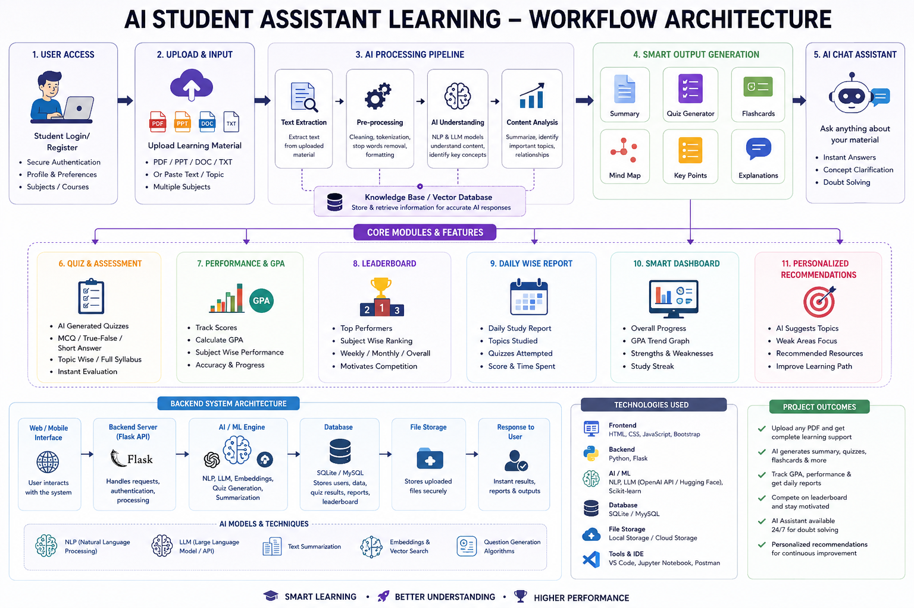
Fig. 2.1 System Architecture of the AI-Powered Student Assistant Learning System
2.7 Data Flow
The student accesses the web application and uploads or provides supported learning content. The application extracts and prepares relevant information for processing. The AI service generates requested outputs such as summaries, flashcards, quizzes, explanations, or study support. Generated resources are presented to the student, while relevant interaction information can support feedback and personalized recommendations.
The data flows from the student to the AI system, where the input is processed and analyzed, the student's learning performance is evaluated, and personalized explanations, quizzes, study materials, and recommendations are returned to the student. Thus, the data continuously flows from the student to the AI processing modules and back to the student in the form of personalized learning assistance, helping improve understanding, engagement, and overall academic performance, as shown in the Figure 2.2.
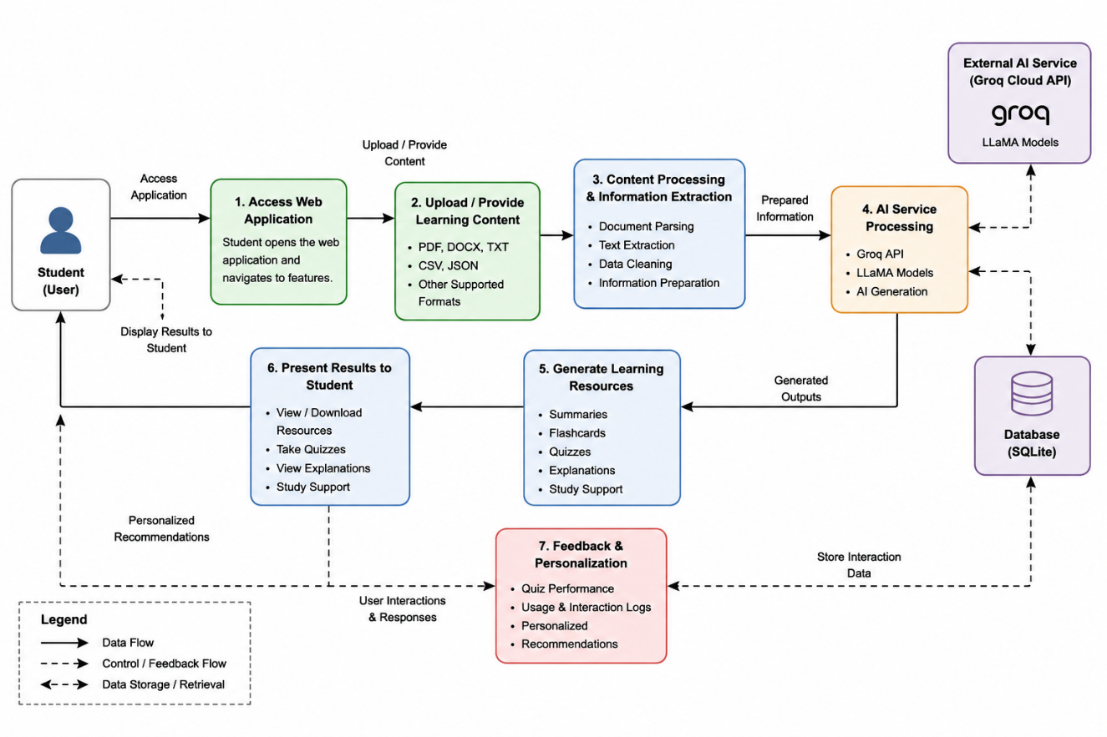
Fig. 2.2 Data Flow of the AI-Powered Student Assistant Learning System
2.8 Technology Stack
The technology stack combines Python and Flask for backend development, HTML5, CSS3, JavaScript, and Jinja2 for the interface, Groq API with supported LLaMA models for AI-assisted generation, document-processing libraries for content extraction, and SQLite or PostgreSQL for data support. The AI Student Assistant Learning system uses Python as the primary programming language for AI and backend development.
Natural Language Processing (NLP) techniques are used to understand student queries and generate relevant learning assistance. Machine Learning and Generative AI models are used for personalized content generation, quizzes, and performance analysis. HTML, CSS, and JavaScript are used to develop an interactive and user-friendly interface for students.
MySQL/SQLite is used to store student profiles, quiz results, learning progress, and interaction history. The system uses Python for backend development, AI, and machine learning. NLP and Generative AI technologies are used to understand queries and generate learning content.

CHAPTER 3
TECHNICAL IMPLEMENTATION AND CORE MODULES
3.1 Project Implementation Overview
The AI-Powered Student Assistant Learning system was implemented as an end-to-end web-based application integrating Artificial Intelligence, Natural Language Processing, document processing, backend development, database support, and frontend development.
The application receives supported learning material and prepares relevant content for downstream processing. The AI service is used to generate learning resources such as summaries, revision notes, flashcards, quizzes, explanations, and study-planning outputs. The implementation follows a modular approach in which content processing, AI integration, backend services, data management, and frontend components are developed as coordinated modules.
3.2 Algorithm / Execution Steps
- Input: Receive the student's learning request and supported study material through the application interface.
- Content extraction: Extract or prepare relevant textual information from the selected document or learning input.
- Context preparation: Clean and organize the extracted information into suitable context for the requested learning task.
- Feature selection: Identify the requested operation, such as summary generation, flashcards, quiz generation, explanation, or study planning.
- AI generation: Send the prepared context and request to the configured AI service and receive the generated response.
- Assessment support: Where quizzes are generated, present questions and use the available responses to provide feedback and revision support.
- Data management: Store or retrieve relevant learning and interaction information through the configured database layer.
- Output: Display the generated learning resources and available analytics through the web application.
3.3 Study Material Processing
The study material processing module receives supported learning content and prepares it for downstream AI operations. Depending on the file format and configured implementation, document-processing utilities extract textual information that can be organized into a usable context.
The prepared content is associated with the requested learning feature so that the application can generate resources that remain relevant to the selected study material.
3.4 AI Content Generation
The AI content generation module uses the configured Groq API and supported LLaMA models to produce learning-oriented outputs. Prompts and extracted context are prepared according to the selected task.
The module can generate concise summaries, key points, revision notes, explanations, flashcards, practice questions, and other requested educational resources. Generated outputs are returned to the application interface for student use.
3.5 Quiz and Feedback Module
The quiz module generates questions from selected learning content to support self-assessment. Students can use the generated questions to test their understanding and identify topics that require further revision.
Where feedback is available, the system presents explanations or guidance that helps students understand incorrect responses and reinforce important concepts.
3.6 Personalized Learning and Study Planning
The personalized learning module organizes selected study-planning and recommendation features. Available learning interactions and performance-oriented information can be used to support revision priorities and structured study activities.
The study-planning functions are intended to help students manage learning time, prioritize topics, and maintain a consistent revision routine.
3.7 Backend Development
The backend was developed using Python and Flask. The backend coordinates user requests, document processing, AI service communication, application logic, and database interactions.
The backend receives requests from the web interface, forwards relevant context to the required processing modules, receives generated results, and returns the outputs to the frontend.
3.8 Database Implementation
SQLite and/or PostgreSQL are used according to the configured project environment to support storage and retrieval of relevant learning and application information. The database layer can support user-related records, learning interactions, generated outputs, and selected performance information.
3.9 Frontend Development
The frontend was developed using HTML5, CSS3, JavaScript, and Jinja2. The interface provides accessible navigation for study material processing, AI-generated learning tools, self-assessment, and selected academic-support features.
3.10 System Integration and Workflow
The individual modules were integrated to form a complete learning-support application. The workflow begins when a student provides supported learning material or selects an AI-assisted feature through the web interface.
The backend prepares the relevant content, coordinates the AI service request, and returns the generated output to the application. Relevant interactions can be stored through the database layer, while the interface presents learning resources, feedback, and available performance-oriented information.

CHAPTER 4
TESTING, VERIFICATION AND QUALITY ASSURANCE
4.1 Testing Overview
Testing and verification were carried out to examine whether the AI-Powered Student Assistant Learning system performed its intended functions correctly. The testing process covered major modules, including study material processing, AI-assisted content generation, quizzes, performance-related features, and database operations.
The application was tested through practical execution using supported learning materials and available project data. The evaluation focused mainly on functional behavior and qualitative verification because the project does not use a controlled benchmark dataset for formal statistical evaluation of every AI-generated feature.
4.2 Functional Verification
Functional verification was performed to confirm that students could access the main learning modules through the web application. The tested workflow included navigation, providing learning content, processing supported materials, and accessing the different AI-assisted learning features.
The generation of summaries, revision notes, flashcards, quizzes, and explanations was also verified through practical system use. Relevant outputs were checked to ensure that requests were processed successfully and that the generated learning resources were displayed through the appropriate application interface.
4.3 AI Content and Integration Verification
AI-generated content was reviewed by providing learning material and requesting different types of educational resources. Generated summaries, notes, flashcards, explanations, and quiz content were checked for relevance to the selected learning input and successful delivery to the application.
Integration verification examined communication between the frontend interface, Flask backend, AI service, document-processing components, and SQLite database layer. The complete workflow was checked from content input and processing to AI response generation, storage of relevant records, and presentation of results.
4.4 Performance Validation and Quality Assurance
Performance validation focused on the practical responsiveness of the system during normal application usage. The processing of learning materials, generation of AI-assisted outputs, database operations, and presentation of results were observed to ensure that the workflow remained functional and usable.
Quality assurance focused on usability, maintainability, and proper handling of application functions and user inputs. Since AI response time can depend on document size, network conditions, and external service availability, the project emphasizes practical system behavior rather than unsupported performance claims.

CHAPTER 5
RESULTS, OUTPUT ARTIFACTS AND DISCUSSION
5.1 Results Overview
The developed application demonstrates the integration of AI-assisted content generation, document processing, self-assessment, personalized learning support, and web-based interaction. The following figures present representative output artifacts from the implemented system.
5.2 Student Dashboard and Performance Overview
The student dashboard provides a centralized interface through which learners can access study tools, generated resources, and selected academic-support features. It serves as a convenient entry point for navigating between the different modules available in the application. The dashboard helps organize learning activities and provides quick access to important features. This improves the overall usability of the system.
The dashboard also presents selected performance-related information in a structured manner for easy viewing. Students can access uploaded materials, quizzes, learning resources, and other available academic-support functions from one interface. This centralized arrangement reduces unnecessary navigation between different sections of the application. It supports a more organized and convenient learning workflow, as shown in the Figure 5.1.
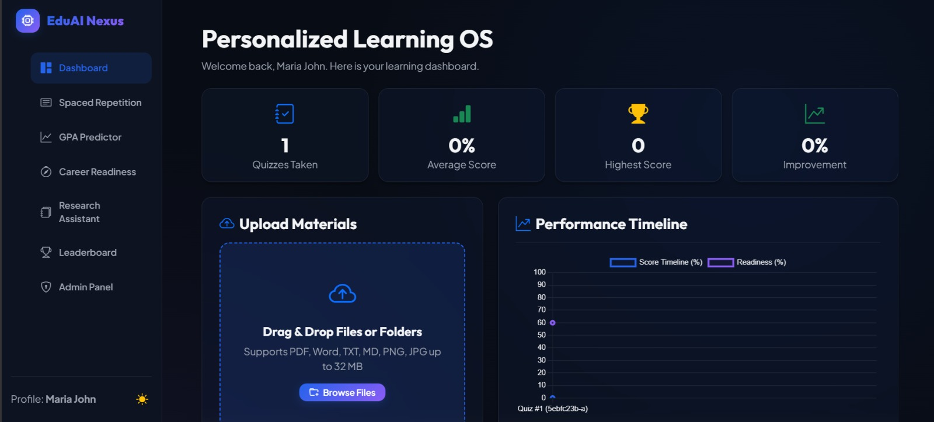
Fig. 5.1 Student Dashboard and Performance Overview
5.3 AI-Generated Quiz Assessment
The quiz module automatically generates questions based on the selected learning content and presents them through an interactive assessment interface students can attempt the generated questions by selecting suitable answers from the available options. This provides an interactive method for reviewing the processed study material and testing conceptual understanding.
The generated assessment helps students identify concepts that may require further revision and reinforcement. Quiz responses and results can also provide performance-related information for self-assessment. This feature extends the system beyond content generation by allowing students to actively evaluate their learning progress, as shown in the Figure 5.2.
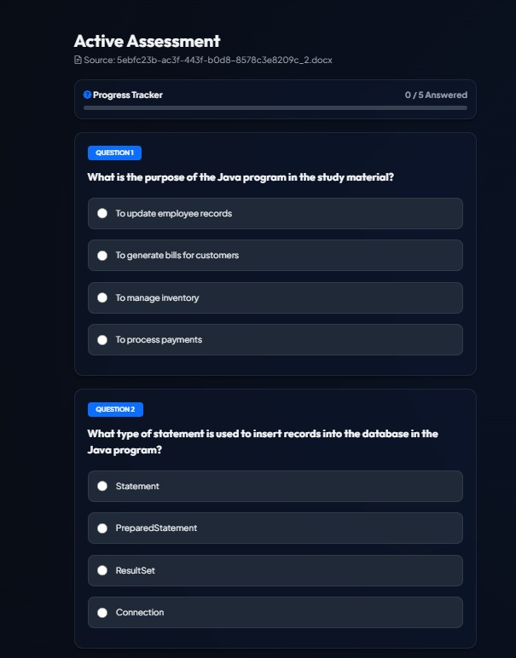
Fig. 5.2 AI-Generated Quiz Assessment
5.4 AI-Generated Study Summary
The system generates study summaries from the selected or uploaded learning material using the configured AI-assisted processing workflow. The generated output presents the important concepts from the source content in a structured and readable format. Students can access the summary through the application interface for revision purposes.
The summary-generation feature reduces the manual effort required to identify and organize important information from study materials. Different available summary formats can support students according to their learning requirements. This provides a convenient resource for reviewing content before moving to other learning activities, as shown in the Figure 5.3.
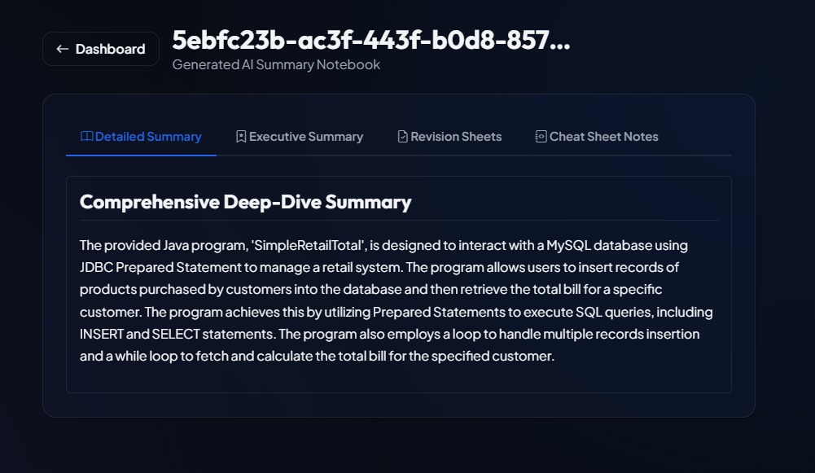
Fig. 5.3 AI-Generated Study Summary
5.5 Personalized Learning and Study Planning
The personalized study-planning feature provides structured learning guidance based on the available study requirements and selected learning information the system presents a study plan organized into different time-based learning activities. Students can use the generated plan to structure their revision routine.
The study plan helps organize learning tasks and encourages students to focus on important topics in a systematic manner. The feature combines AI-assisted learning resources with structured study support. This contributes to a more organized learning workflow and supports consistent academic preparation.
Students can organize their preparation by setting learning goals and planning study activities for different subjects. The system can suggest suitable topics, practice tasks, and revision activities according to the student’s progress. This approach helps students follow a structured study routine while focusing more on areas that need improvement, as shown in the Figure 5.4.
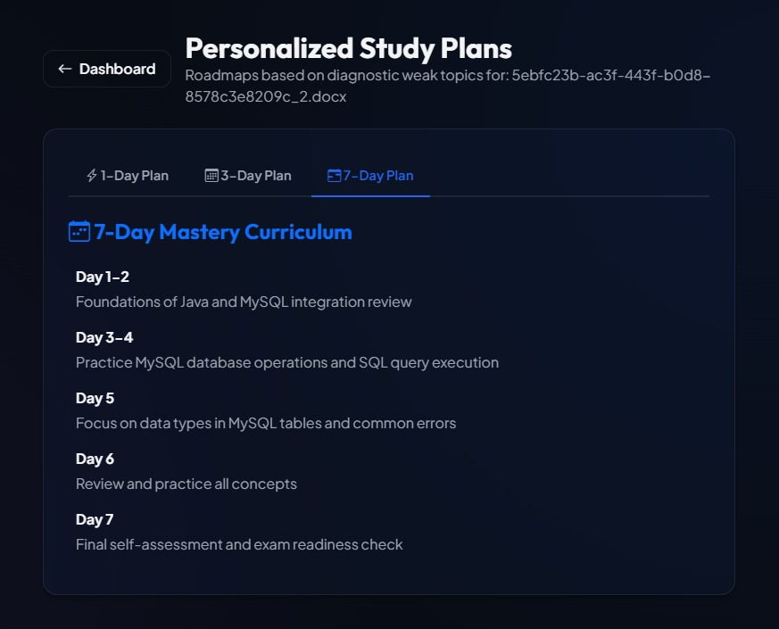
Fig. 5.4 Personalized Study Plan
5.6 Academic Performance and GPA Analysis
The application includes an academic performance and GPA-related module for presenting selected performance information in a structured dashboard. The interface displays predicted GPA and other available academic performance metrics. This allows students to view relevant information from a centralized screen.
The performance-oriented module can help students review their academic progress and identify areas that may require additional attention. The displayed information supports self-assessment and academic planning within the application. This feature complements the learning resources by connecting study activities with performance-related support.
The predicted GPA gives students an early indication of their current academic standing and helps them understand the impact of their performance. Based on the prediction, the system can suggest subjects or areas where additional preparation may be beneficial. This feature supports better academic planning and encourages students to take timely action to improve their overall performance, as shown in the Figure 5.5.
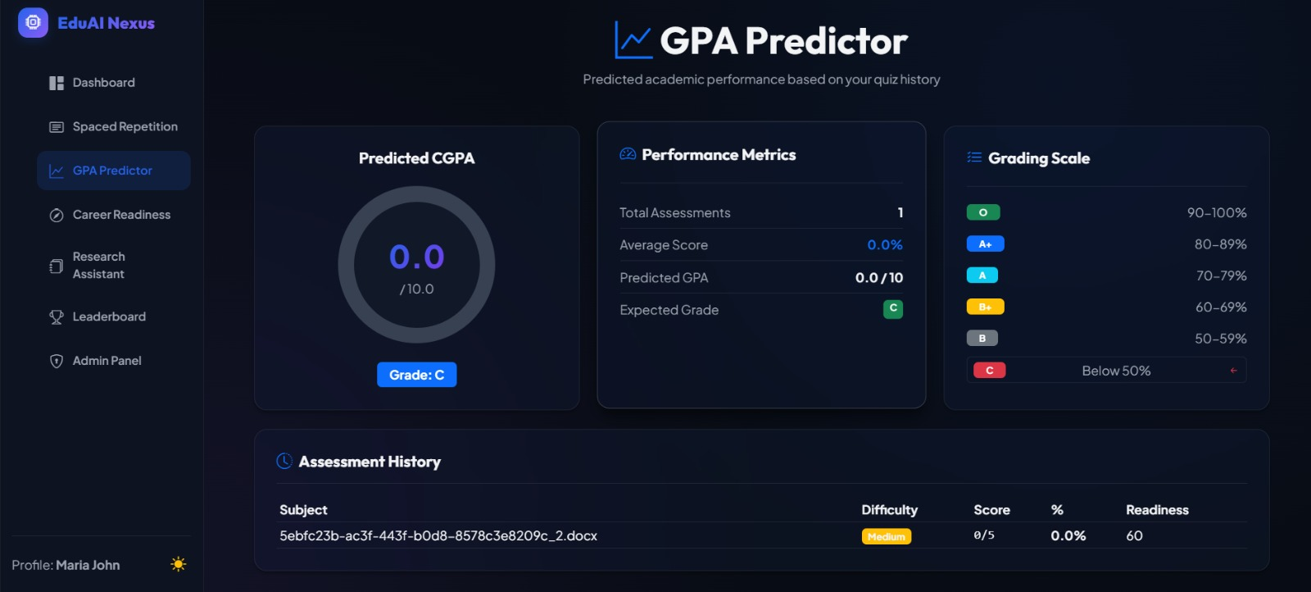
Fig. 5.5 GPA Analysis Dashboard
5.7 User Interface and Output Artifacts
The web interface presents the different learning modules through accessible screens and organized navigation options. Students can access features related to study material processing, summaries, quizzes, flashcards, study planning, and performance-oriented functions. The interface acts as the main point of interaction between the student and the application.
The output artifacts generated by the system are presented through their respective application pages. These include summaries, quizzes, study plans, and performance-related views, depending on the selected feature. The organized presentation of these outputs helps students access and use the generated learning resources efficiently.
5.8 Discussion and Summary of Results
The observed results demonstrate the practical integration of AI-assisted generation with conventional web application components. The system processes learning materials and provides different educational resources through a unified application environment. The implemented modules work together to support content processing, learning activities, and selected academic-support functions.
The project demonstrates how Generative AI can be applied to develop an organized student learning-support platform. However, the quality and response time of AI-generated content may vary depending on the input material, prompt context, network conditions, and configured AI service. AI-generated outputs should therefore be reviewed when high academic precision is required.

CHAPTER 6
CHALLENGES ENCOUNTERED AND SOLUTIONS
6.1 Challenges During System Development
The development of the AI-Powered Student Assistant Learning system involved integrating document processing, AI services, backend development, database management, and frontend interfaces. Coordinating these different components required careful handling of user inputs, processed content, generated outputs, and communication between the application modules.
Another challenge was managing multiple learning features within a single application. Features such as summarization, flashcard generation, quizzes, explanations, and study support require different processing workflows. A modular application structure was therefore used to organize these functions and improve system maintainability.
6.2 AI Integration Challenges and Solution
AI-generated responses can vary depending on the quality and length of the input content, prompt wording, and AI service availability. Generating meaningful learning resources required the application to prepare relevant content before sending requests to the configured AI service.
This challenge was addressed by using structured, feature-specific prompts for different learning tasks. Appropriate error handling was also incorporated to manage API-related issues and unsuccessful requests, helping the application provide a more reliable AI-assisted learning experience.
6.3 Content Processing and Integration Challenges
Learning materials can differ significantly in their file format, structure, length, and quality of content. Extracting relevant text from uploaded materials and preparing it for AI processing was therefore an important challenge during the development of the system.
The application separates file validation, content extraction, and AI processing into different stages. This structured approach helps maintain the quality of the processing workflow and allows the system to handle supported learning materials more effectively.

6.4 Performance and Data Challenges
System performance can depend on several factors, including document size, content length, AI service response time, network conditions, and available computing resources. Large learning materials or detailed AI requests may require additional time for processing and generating results.
To address these issues, the system performs processing based on the learning feature selected by the user. SQLite provides structured storage for learning materials, generated flashcards, quiz results, and related information, supporting efficient retrieval and management of application data.
6.5 Overall Solutions Applied
The challenges encountered during development were addressed through a modular system architecture, structured content processing, AI service integration, and database-backed storage. Input validation and error-handling mechanisms were also incorporated to improve the reliability of the application.
These solutions enabled the individual components to work together as a unified AI-Powered Student Assistant Learning system. The modular approach also supports future improvements by allowing individual features and processing components to be updated without redesigning the complete application.

CHAPTER 7
CONCLUSION AND FUTURE ENHANCEMENTS
7.1 Conclusion
The AI-Powered Student Assistant Learning project was developed as an intelligent educational platform that applies Artificial Intelligence to simplify and enhance the learning process. The application transforms supported learning content into useful resources such as summaries, revision notes, flashcards, quizzes, explanations, and personalized study support.
The project integrates Python and Flask, web technologies, document processing, Groq API with supported LLaMA models, and database support to create a practical end-to-end application. The work also demonstrates the technical competencies gained during the AI GPU Summer Internship in AI, Generative AI, Large Language Models, GPU-enabled computing, and Full-Stack Web Development.
  - Future Enhancements
Integrate additional advanced AI models and evaluation mechanisms for improved personalization and output quality. Develop mobile and voice-based interfaces for more accessible learning support. Add multilingual learning features and broader support for different academic content formats. Expand performance analytics, recommendation methods, and university-related learning service. Advanced analytics can be introduced to provide deeper insights into student performance and learning patterns.
The GPA prediction module can be improved with more academic parameters to produce more reliable predictions. A mobile application can also be developed to provide students with convenient access to the learning assistant anytime and anywhere. Voice-based interaction can be added to allow students to ask questions and receive responses through speech. In the future, the system can be enhanced with advanced AI models to provide more accurate and personalized learning support. The system can also include a smart notification feature to remind students about upcoming quizzes, assignments, revision sessions, and planned study activities.

REFERENCES
[1]. ByteTrack. “ByteTrack Documentation.” Resources for multi-object tracking.
[2]. FastAPI. “FastAPI Documentation.” Official guide for building web APIs.
[3]. Flask. “Flask Documentation.” Official guide for the Flask web framework.
[4]. Groq. “Groq Documentation.” Guide for AI inference and API integration.
[5]. Meta AI. “LLaMA Models.” Official resources for large language models.
[6]. NVIDIA. “Deep Learning Documentation.” Resources for AI development.
[7]. PyMuPDF. “PyMuPDF Documentation.” Guide for PDF processing and extraction.
[8]. Pypdf. “pypdf Documentation.” Guide for PDF reading and extraction.
[9]. Python. “Python Documentation.” Official Python language reference.
[10]. Python-docx. “Documentation.” Python library for DOCX processing.
[11]. SQLite. “SQLite Documentation.” Guide for databases and SQL operations.
[12]. Ultralytics. “YOLO Documentation.” Official resources for YOLO object detection.

APPENDICES
APPENDIX A
Source Code
The selected source code of the AI-Powered Student Assistant Learning System is presented in this appendix. The code includes backend configuration, learning material processing, AI-assisted content generation, database operations, and software dependencies.
A.1 Backend Application Configuration
The backend application is implemented using Python and Flask. The initial configuration imports the required libraries, configures logging, initializes the Flask application, defines the upload folder and supported file formats, and initializes the Groq API client for AI-assisted processing. The backend manages communication between the user interface, AI modules, database, and other services. It handles student requests, processes the submitted data, and sends the required results back to the frontend. Configuration includes setting up the application server, database connection, API endpoints, environment variables, and required software libraries.
It also manages authentication, data validation, error handling, and secure communication. Proper backend configuration ensures that features such as AI-based question answering, quiz generation, performance analysis, personalized recommendations, and GPA prediction work smoothly. The backend can also be structured into separate modules so that new features can be added and existing components can be maintained easily. Security configurations help protect student information and prevent unauthorized access to the application. Proper configuration improves the reliability, scalability, and overall performance of the system. It also maintains user sessions and manages communication with external AI services when required. Regular backend configuration and maintenance help the system remain stable and support future enhancements. The backend coordinates different requests and delivers accurate results to the student interface. It provides a strong foundation for integrating additional AI-based learning features in the future, as shown in the Figure A.1.

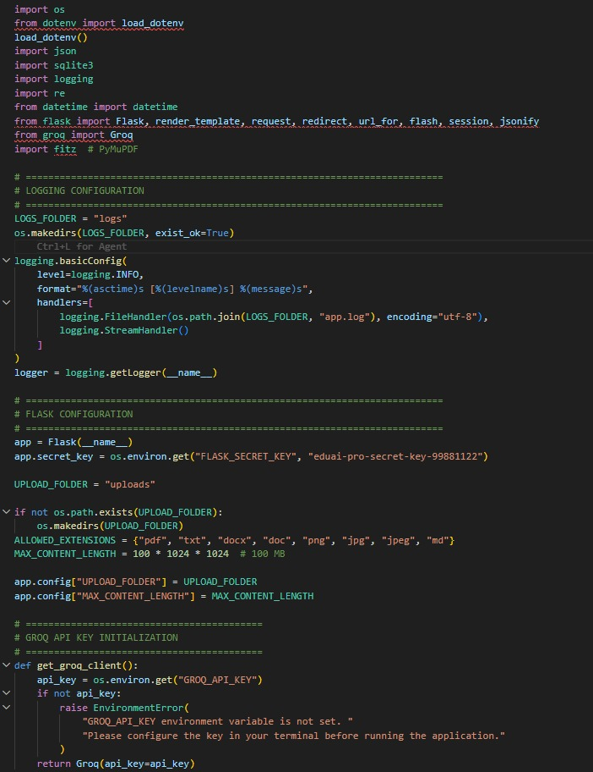
Fig. A.1 Backend Application Configuration Code
A.2 Learning Material Processing and Storage
The learning material processing module handles uploaded files and extracts their textual content for further processing. The application generates summaries and flashcards from the extracted content and stores the learning material and generated resources in the database. The system processes uploaded learning materials such as notes, PDFs, and documents to extract useful content for personalized learning. The processed materials and relevant student data are securely stored and retrieved when required for explanations, quizzes, and revision, as shown in the Figure A.2.
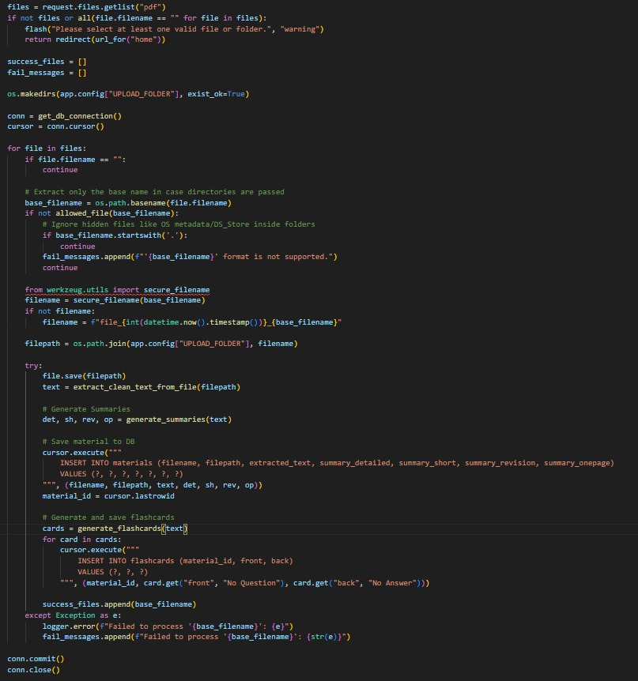
Fig. A.2 Learning Material Processing and Storage Code
A.3 Software Dependencies
The software dependencies required for the application are maintained in the requirements.txt file. These libraries support backend development, AI service integration, document processing, web application functionality, and database connectivity. The project requires Python libraries and frameworks for AI, NLP, machine learning, and backend development. Database and API dependencies are used to manage student data and communication between different system modules. These dependencies ensure that the AI assistant, quiz generation, performance analysis, and recommendation features work correctly, as shown in the Figure A.3.
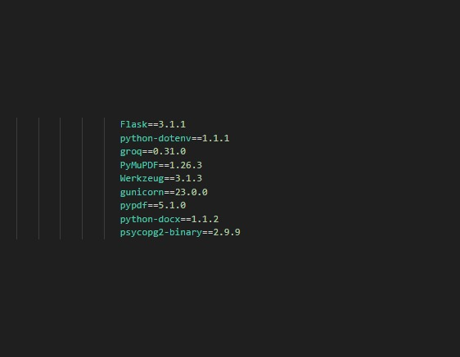
Fig. A.3 Software Dependencies

APPENDIX B
B.1 DATABASE DDL SCRIPT
The AI-Powered Student Assistant Learning system uses an SQLite database to store learning materials, generated flashcards, and quiz performance records. The database structure consists of three main tables: materials, flashcards, and quiz_results.
The materials table stores uploaded learning material information, extracted text, and different types of AI-generated summaries. The flashcards table stores generated question-and-answer flashcards associated with the corresponding learning material.
The quiz results table stores quiz performance information, including scores, weak topics, study plans, readiness scores, confidence, and tutor feedback. The script also defines appropriate data types, constraints, and default values for each database field. It helps organize student records and ensures that information can be stored and retrieved efficiently. It creates tables for student profiles, subjects, study materials, quizzes, quiz results, and learning progress. Primary keys and foreign keys are used to establish relationships between different tables and maintain data consistency.
The DDL script defines the database structure required for storing student and learning-related information. The DDL script provides a structured foundation for managing the data required by the AI learning system. Performance records can be used to track scores and monitor academic progress over time. GPA-related tables store semester-wise or subject-wise academic information required for prediction. Relationships between tables allow the system to connect students with their subjects, quizzes, materials, and results. Constraints such as NOT NULL, UNIQUE, PRIMARY KEY, and FOREIGN KEY help maintain reliable database records. Indexes can be added to frequently searched fields to improve database query performance. The DDL script also supports modification of the database when new learning features are introduced. The subject table stores details about the courses or topics available for learning. Learning-material tables maintain information about uploaded files, notes, summaries, and related resources. Overall, it provides a well-structured and scalable database foundation for the complete application, as shown in the Figure B.1.
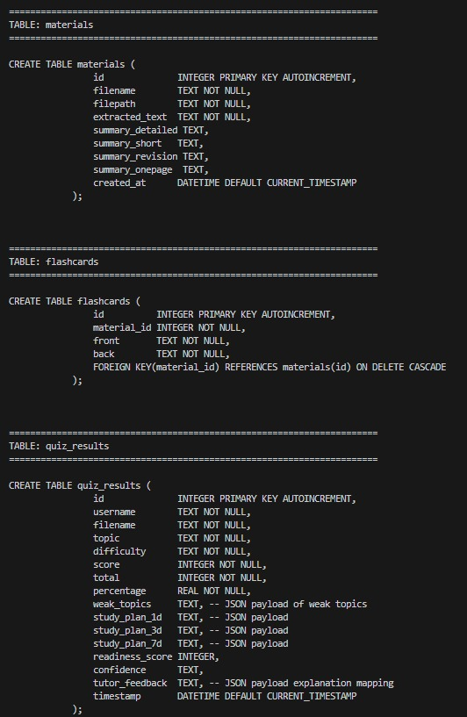
Fig. B.1 Database DDL Script of the AI-Powered Student Assistant Learning System
The database structure supports the storage and retrieval of learning content and performance-related information required by the application's AI-assisted learning features.
APPENDIX C
User Handbook
C.1 Accessing the Application
Open the web application through the configured application address and select the required learning feature from the available interface. Users can navigate through the different sections of the application to access learning materials and AI-assisted functionalities. The interface is designed to provide a simple and organized learning experience.
C.2 Uploading Learning Material
Provide supported learning content and select the required processing or generation option. Users can upload relevant documents or learning materials for further analysis and processing. The system extracts the required information and makes it available for the selected AI-assisted learning features.
C.3 Generating Learning Resources
Use the available features to generate summaries, notes, flashcards, quizzes, explanations, and other supported outputs. Users can select the required functionality based on their learning needs. The generated resources help organize information and support effective revision and self-learning.
C.5 Personalized Study Support
Use available planning and performance-oriented features to organize study activities and monitor learning progress. The application can support personalized learning by presenting relevant information based on user interactions and learning requirements. These features help users maintain a more structured study process.
C.6 User Guidelines
Review AI-generated content before using it for important academic purposes and verify the information when necessary. Avoid uploading sensitive or confidential information unless the deployment environment provides appropriate safeguards. Users should use the application responsibly and treat AI-generated results as supportive learning resources rather than a replacement for independent understanding.

APPENDIX D
Day-wise Work Progress
The internship was conducted over a ten-day period, covering important concepts and practical areas of Artificial Intelligence, Machine Learning, Deep Learning, Generative AI, and Full-Stack Development. Each day focused on a specific topic, providing a structured learning experience that combined theoretical understanding with practical applications. The following section presents the day-wise activities and learning outcomes achieved during the internship.
D.1 Day 1 - GPU Environment Setup
The internship began with understanding the GPU-enabled working environment. I learned about pod creation, resource allocation, and launching JupyterLab with GPU support. I also understood the importance of proper environment configuration for AI development.
D.2 Day 2 - Artificial Intelligence and Machine Learning
I studied the fundamentals of Artificial Intelligence and Machine Learning. The session covered AI concepts, machine learning types, data, features, models, training, testing, prediction, supervised learning, and unsupervised learning.
D.3 Day 3 - Neural Networks
I studied the fundamentals of neural networks, including neurons, input layers, hidden layers, output layers, weights, biases, and activation functions. I also understood how neural networks process data and identify patterns.
D.4 Day 4 - Deep Learning
The session focused on Deep Learning and multi-layer neural network architectures. I studied feature extraction, Deep Learning applications, dataset requirements, and the computational resources required for training Deep Learning models.
D.5 Day 5 - Full-Stack Development
I explored the Antigravity tool and revised Full-Stack Development concepts. I learned the roles of the frontend, backend, and databases and understood how these components communicate to form a complete software application.

D.6 Day 6 - Transformer Architecture
I studied Transformer architecture and attention mechanisms, including encoder-decoder structures and multi-head attention. I also learned how Transformers process contextual information and their applications in modern Natural Language Processing systems.
D.7 Day 7 - Large Language Models
The session focused on Large Language Models and efficient fine-tuning techniques. I learned about LoRA, PEFT, transfer learning, model customization, and optimization methods for specialized AI applications.
D.8 Day 8 - Generative AI
I studied Generative AI and image generation using Stable Diffusion XL. I explored text-to-image generation, prompt engineering, and the effect of different prompts and model configurations on generated outputs.
D.9 Day 9 - GPU Optimization
I learned GPU optimization techniques for improving AI model performance. The topics included mixed-precision training, memory optimization, FlashAttention, tensor parallelism, and efficient GPU resource utilization.
D. 10 Day 10 - Capstone Project and Evaluation
The internship concluded with the capstone project presentation and technical review. I presented the project implementation, discussed challenges and future improvements, received feedback from mentors, and reviewed the concepts learned throughout the internship.

